Note-Taking and Note-Making
- Teacher assigns a buddy who helps a newcomer student to take notes
- Mainstream teachers keep a notebook of lesson big ideas and key vocabulary to share with BAIs so they can preview and/or review with students
- Oxford Picture Dictionary for the Content Areas
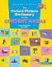
  - Teacher copies and pastes images into a vocabulary notebook for beginners to label with a word or simple phrase
- Teacher uses the vocabulary feature on Read&Write 10 to create vocabulary lists with picture support.
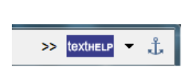Click the double arrow drop-down for the vocabulary feature.
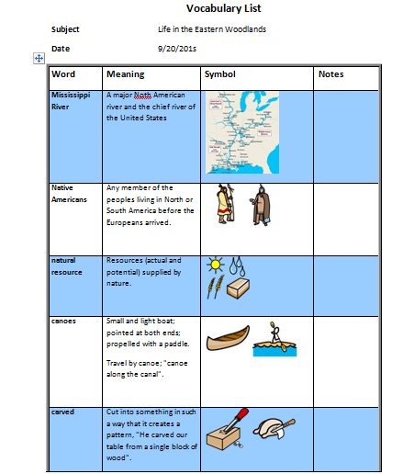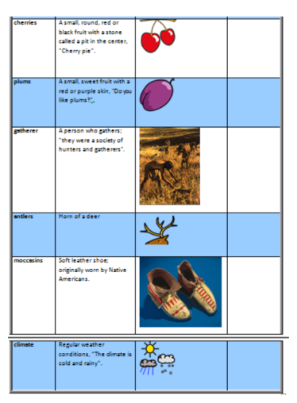

- Teacher provides a picture for students to label with important vocabulary words in a word bank:
canoe
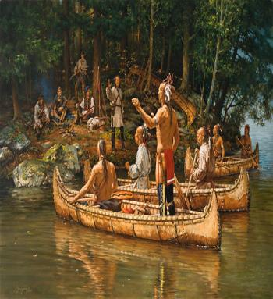
Natural resource
Word Bank
forest canoe lake
Native American
natural resource
forest
Native American

lake

The teacher adds a short paragraph pulling these terms together using simple sentences. She then gives the students the paragraph again with the key vocabulary deleted and they fill it in.
- Benchmark Universe Talking E-Books
  - Leveled books with content connections designed for English learners. These books are interactive to build fluency and comprehension.

http://www.benchmarkuniverse.com/
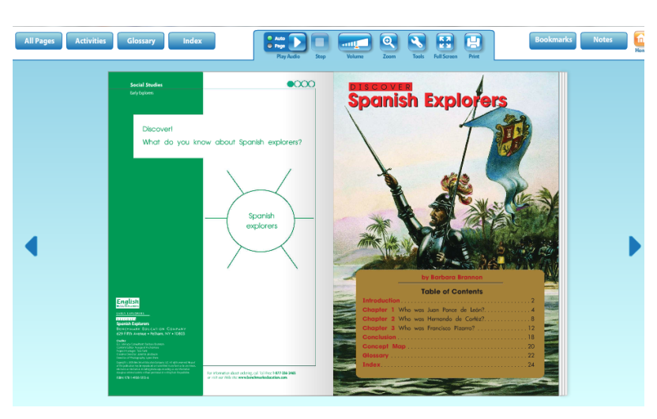

- Webbing using key vocabulary and phrases from the text or notes
  - Adding visuals increases comprehension
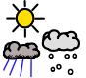

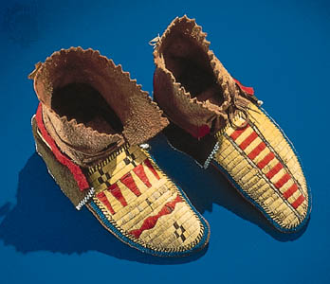
Eastern Woodlands

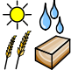

Fill-in the Blanks
Teacher provides students with two copies of the same passage from a content area book or a picture book. The first one services as the key. The second passage has missing words. Students use the key passage to help them fill in the missing vocabulary words.
Example:
Tropical rainforests are among the most mysterious of all geographical biomes in the world. A biome is an area with very distinctive plants and animals that have adapted to life in that particular environment. Rainforests have covered large portions of the Earth for millions of years, and can have trees that are 1,000 years-old or more. They are called rainforests because they are among the wettest areas on Earth, receiving anywhere from 80 to 100 inches of rain a year. In most rainforests, the temperature ranges from 70 to 85 degrees Fahrenheit all year long, and the air is almost always humid (http://www.superteacherworksheets.com/reading-comp/5th-rainforest1_RAINF.pdf)

Tropical _____________are among the most _______________ of all geographical ___________ in the world. A ______________ is an area with very _________________ plants and animals that have ____________ to life in that particular _____________. _______________ have covered large ________________ of the Earth for millions of years, and can have trees that are ______________ or more. They are called _____________because they are among ________________ areas on Earth, receiving anywhere from 80 to 100 inches of rain a year. In most ________________, the ________________ ranges from 70 to 85 degrees __________________ all year long, and the air is almost always ______________ (http://www.superteacherworksheets.com/reading-comp/5th-rainforest1_RAINF.pdf)

Can You Recognize That Word?

Teacher provides students with a word bank with many key vocabulary terms for the lesson. Students highlight words as the teacher discusses them when given a non-verbal cue by the teacher during the lesson.
If teacher writes notes on the SMART board and students recognize them as the words in their word bank, they highlight them as well.
(Variation): Teacher provides notes to students in advance. Student highlight key vocabulary words when a non-verbal cue is given by the teacher.
Example:
Continent, ocean, hemisphere, equator, latitude, longitude, meridian, analyze, determine, explain

Jigsaw Puzzle Passage
Students benefit from multiple exposures to the same text. Teacher provides students with a passage from a content area book or a picture book. This passage will service as the key. Teacher also provides students with the same passage cut into separate sentences (either the entire passage or several sentences from the passage). Students look at the key passage and try to put the sentence strips in order.
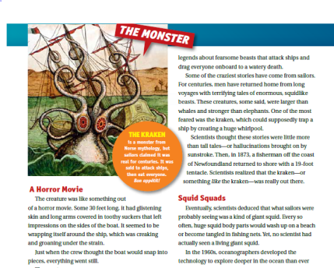
Example: http://teacher.scholastic.com/scholasticnews/magazines/scope/pdfs/SCOPE-031212-PairedText.pdf

Squid Squads

A Narrow Movie

The creature was something like out of a horror movie.

Just when the crew thought the boat would snap into pieces, everything went still.

